Full moon party mecca looks for sustainable growth model
Bamrung Amnatcharoenrit
Koh Pha-ngan, Surat Thani September 23, 2013
Is Pha-ngan's Haad Rin a tourist paradise lost?
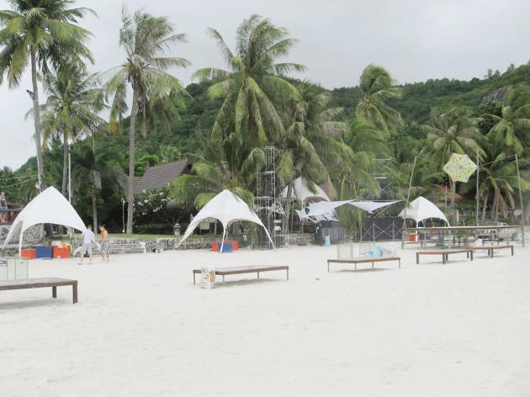
Haad Rin Beach on Koh Pha-ngan was packed with foreign revellers for a full-moon party on Thursday night. Even amid rains and storm, the white-sand beach remains a party paradise for tourists around the world.
The wild party with more than 20,000 people started early. Many of the revellers showed up with painted faces and bodies. As they turned up the volume of the music, more tourists flocked in with drinks in their hands. Some jumped up on the stage to move their hips to the music.
This was the 32nd year of the full-moon party. Through these three decades, this southern island off the Gulf of Thailand has carved a niche for itself on the tourism map, bringing economic vitality to the local community with tourism revenue of more than Bt10 billion in 2012 through job creation and tourism-related business growth.
During the peak season, the number of night party-goers is estimated to double and reach 100,000 for New Year celebrations. However, its rapid growth in the past 18 years has created a headache, too. Thanyah Phoolsawad, president of Koh Pha-ngan Hotels Association, told The Nation that it was clear the island was growing without any direction. It's plagued by problems of spoiled environment, safety, shortage of skilled labour, and excessive construction of new hotels, he said.
"’The island is at the crossroads at present after witnessing a rapid growth for long years. We need to do something to create sustainable growth in the long term," he said.
Currently, there are more than 12,000 rooms to welcome more than 500,000 tourists who visited last year. The number of visitors is projected to increase more than 10 per cent this year. Currently, they are from Europe, Israel, and China. Clearly, the continuous influx of tourists has forced the local people to open new hotels to serve them without studying the environmental impact and room supply situation. It has been found that rooms were mostly empty during the non-full moon period.
There is a serious shortage of skilled labour. At present, 80 per cent of them are from Myanmar. And 80 per cent of hotel operators are locals who lack management skills in running a business professionally.
Currently, there are more than 200 operators here, offering rooms priced from Bt500 to Bt40,000. About 170 operators are members of the association.
Local operators said safety was a concern. Today, there are 38 police in total, including tourist police, to take care of half a million tourists and local people.
Last Wednesday, Tourism and Sports Minister Somsak Pureesrisak met with local operators on the island to listen to their opinions and problems. After the meeting, he vowed to help them improve the island's capacities to serve tourists and also promote it as a safe island for full-moon parties. Related activities, especially sports and music events, will be promoted additionally on the island to attract more tourists, especially upper middle-income earners, similar to Hua Hin.
Somsak said this would help increase tourism revenue on the island, in line with the government's policy to achieve its tourism revenue of Bt2 trillion in 2015.
Local operators need a helping hand from the government, especially by providing an annual budget to organise activities. They said it was essential for the island to launch more activities to spur its growth throughout the year, and not only full-moon parties. In reality, the government should return something for the island's development because it has contributed a big sum in taxes to the country's coffers annually.
To sustain growth, they want to avoid the Koh Samui model, which has faced problems because of its fast-growing tourism. Thanyah said the island had its own development plan. One of them is to introduce a zoning plan to help save the island and also expand tourist groups.
Under its plan, five zonings will be launched, defined by marketing identity. Health, wellness, therapy, and historical tourism are added as some of the zonings, other than diving and full-moon party destination. Each zone will have its own head and there will be a controlling central body with selected members.

Source: http://nationmultimedia.com/business/Full-moon-party-mecca-looks-for-sustainable-growth-30215405.html

