Full Moon Party Case Study

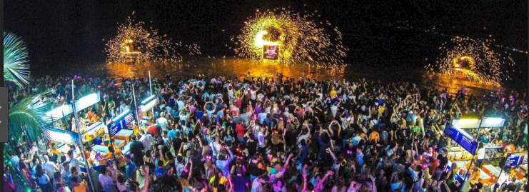

Syllabus Link: Large-scale sporting, musical, cultural or religious festivals as temporary sites of leisure and their associated costs and benefits
• Case study of one festival in a rural location, its site factors and geographic impacts

Use the resources on adorngeo or google classroom to do a case study analysis of the full moon party:
- What? give an overview of the full moon party as a temporary large scale festival.
- Where? give a specific location for the festival and discuss the site factors that have led to it being held there and evolving (it may be useful to include a map)

- When? provide a specific time frame for when the festival began and when it is held

- Why? What factors have led to this being a successful long-term festival?

- Who? Who takes part, who manages, who is impacted by the festival?

Use SEEP analysis to build up notes on the geographic impacts of the full moon party
- Social? Positive/negative

- Economic? Positive/negative

- Environmental? Positive/negative

- Political? Positive/negative

Create a quick mind map visual summary of the issue in the space below

