Factors Influencing Future International Tourism
Syllabus Link: Factors influencing future international tourism, including greater use of social media, international security and diaspora growth
Task: Use the resources on adorngeo to build up notes and examples how various factors may impact the future of international tourism.
Predicted Trends
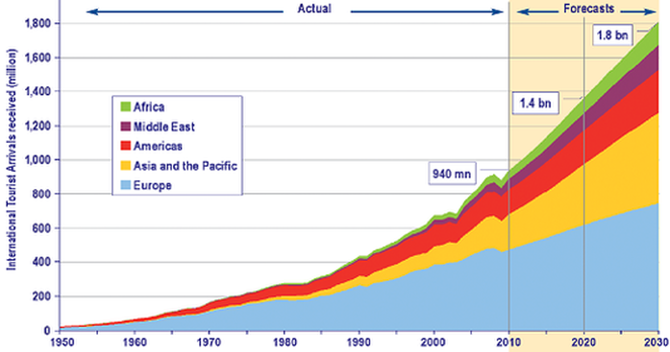
Describe current and predicted trends in international visitor arrival numbers
Explain how factors we have covered already such as increased affluence, awareness and accessibility could impact the future of international tourism.

Influencing Factors
Social Media
International Security
Diaspora Growth
Other factors

Relate to Butlers Model
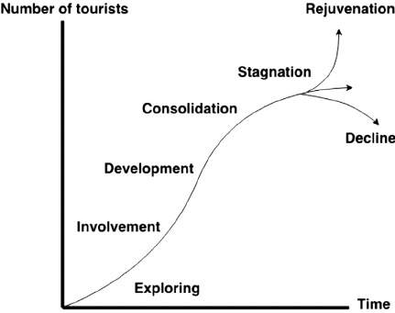
Use the theory of and terminology from Butlers model to describe trends and impacts of future increases in international tourism

