Empowerment and Affirmative Action Notes

Syllabus Link: Empowering women and indigenous or minority groups
- Detailed illustrative examples of affirmative action to close the development gap

Definitions:
- Empowerment: The process of becoming stronger and more confident, especially in controlling one's life and claiming one's rights.

- Affirmative Action: the practice or policy of favoring individuals belonging to groups known to have been discriminated against previously.

Case Studies:

Gender
Case study name: Rwanda – Delivering as one on gender
Background Details:
Where:
When:
Who is driving it and impacted
Project aim:
Note details and evaluate points on the UN SDG rosetta below
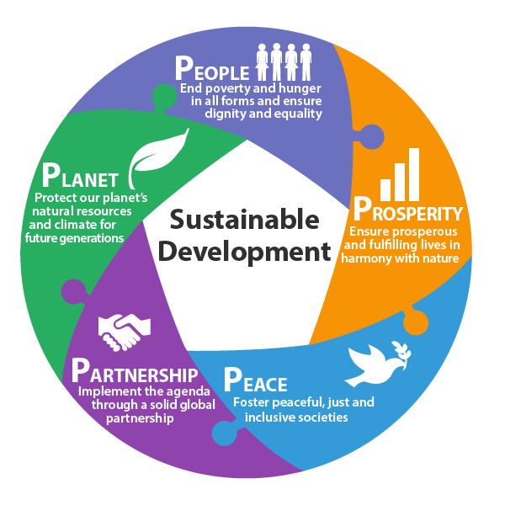

Indigenous Empowerment
Case study name: Green Belt Movement
Background Details:
Where:
When:
Who is driving it and impacted
Project aim:
Note details and evaluate points on the UN SDG rosetta below

Indigenous Affirmative Action
Case study name: Kaikoura Whale Watch
Background Details:
Where:
When:
Who is driving it and impacted
Project aim:
Note details and evaluate points on the UN SDG rosetta below

Minority Groups
Case study name:
Background Details:
Where:
When:
Who is driving it and impacted
Project aim:
Note details and evaluate points on the UN SDG rosetta below

