Ecological Footprint Comparisons
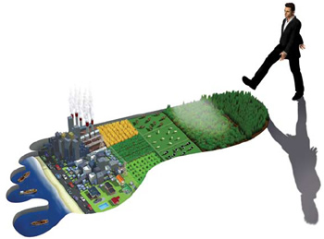
Use the following information to list the countries with the 10 largest and 10 smallest ecological footprints: http://en.wikipedia.org/wiki/List_of_countries_by_ecological_footprint . Don’t forget to write in the unit.
Rank | Largest Ecological Footprint | Smallest Ecological Footprint
1
2
3
4
5
6
7
8
9
10

World Map of Countries by Ecological Footprint
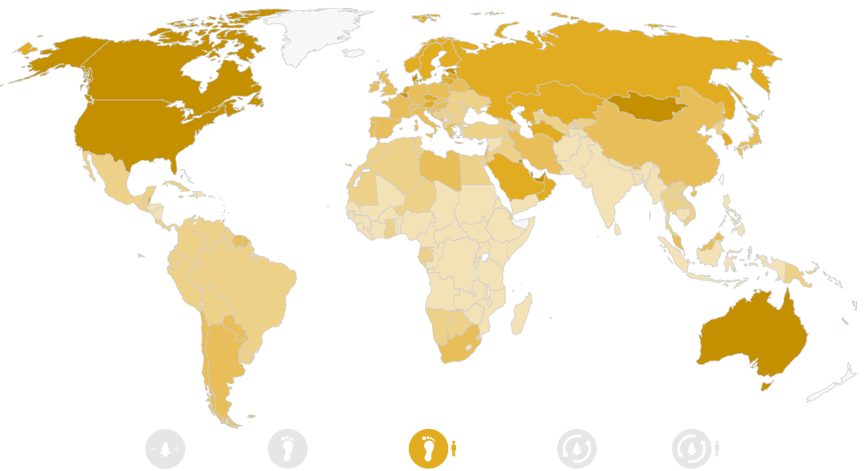
Use the map at http://data.footprintnetwork.org/#/ to describe the global pattern of ecological footprints
In your own words account for the distribution of ecological footprints shown in the map
Do you think the ecological footprint is a useful technique to measure the relationship between population and resource consumption? Justify your response.
What does ecological deficit/ reserve mean?
Describe the global pattern in ecological deficit/ reserve. This can also be found at http://data.footprintnetwork.org/#/
Using examples of specific countries explain the implications of ecological deficits/ reserves.

