Agbogbloshie E-Waste Case Study
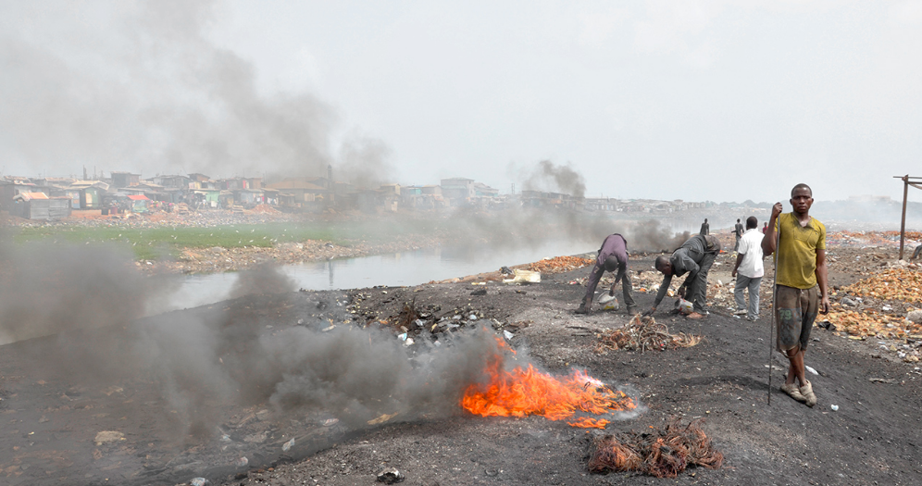
Syllabus Link: The disposal and recycling of consumer items, including international flows of waste

Part 1: Introduction to Ghana
What do you currently know about Ghana?
Locate Ghana on the map below. Then draw arrows to show what countries waste comes from

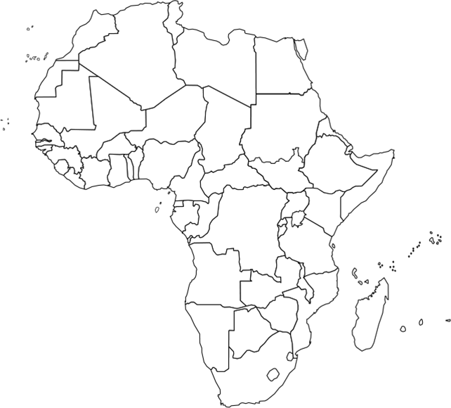

The GDP (PPP) per capita of Ghana is
It is ranked on the UN HDI

Use the resources on Adorngeo to do a case study analysis:
- What? give an overview of the case study

- Where? give a specific relative location

- When? provide a specific time and put the event into context of what was happening around it

- Why? Why does E-waste end up being recycled in Ghana? (think SEEP)

- Who? Who is/was affected? Stakeholders? Who is managing this?

Evaluate the flow of E-waste into Agbogbloshie

- Social? Positive/negative

- Economic? Positive/negative

- Environmental? Positive/negative

- Political? Positive/negative

Create a quick mind map visual summary of the issue in the space below

4 P’s ANALYSIS:
PLACE: Give a specific relative location / comment on scale / describe the relevant physical & human characteristics

PROCESSES: What are the human / physical mechanisms of change relevant to this case study? (think SPEED) Does a specific system apply? (linear, circular, complex, physical, human)

Social (+/-):
Political (+/-):
Economic (+/-):
Environmental (+/-):
Demographic (+/-):

POWER: Who is influencing and affecting change or equilibrium in this case? (citizens, governments, institutions, physical processes, other players?)

POSSIBILITIES: What alternative events, futures, outcomes are possible? To what degree are human / environmental systems able to adapt or change?

