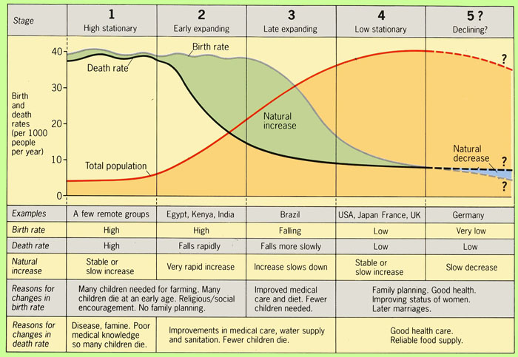
The Demographic Transition Model Activity Sheet

Birth Rate
Death Rate
Natural Increase

Reasons for change in BR
Reasons for change in DR
Named Examples

