Mark Pagel 23 May 2012
Does globalization mean we will become one culture?
Modern humans have created many thousands of distinct cultures. So what will it mean if globalization turns us into one giant, homogenous world culture?
Stroll into your local Starbucks and you will find yourself part of a cultural experiment on a scale never seen before on this planet. In less than half a century, the coffee chain has grown from a single outlet in Seattle to nearly 20,000 shops in around 60 countries. Each year, it’s near identical stores serve cups of near identical coffee in near identical cups to hundreds of thousands of people. For the first time in history, your morning cappuccino is the same no matter whether you are sipping it in Tokyo, New York, Bangkok or Buenos Aries.
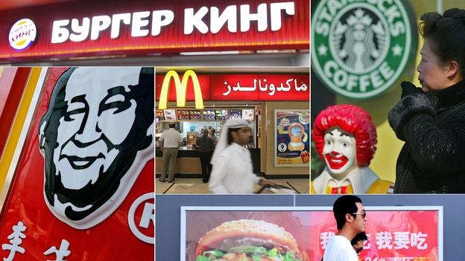
Of course, it is not just Starbucks. Select any global brand from Coca Cola to Facebook and the chances are you will see or feel their presence in most countries around the world. It is easy to see this homogenization in terms of loss of diversity, identity or the westernization of society. But, the rapid pace of change also raises the more interesting question of why – over our relatively short history - humans have had so many distinct cultures in the first place. And, if diversity is a part of our psychological make-up, how we will fare in a world that is increasingly bringing together people from different cultural backgrounds and traditions?
Life savers
In more recent history, this ‘cumulative cultural adaptation’ has been accelerated by the rise of archiving technology. Papyrus scrolls, books and the internet allow us to even more effectively share knowledge with successive generations, opening up an unbridgeable gap in the evolutionary potential between humans and all other animals.
Around 60,000 years ago, cumulative cultural adaptation was what propelled modern humans out of Africa in small tribal groups, by enabling us to acquire knowledge and produce technologies suitable to different environments. Eventually these tribes would occupy nearly every environment on Earth – from living on ice to surviving in deserts or steaming jungles. And amongst each one we see distinct sets of beliefs, customs, language and religion.
‘One world’
Early in our history most of us lived in small bands of maybe 50 to 200 people. At some point tribes formed that were essentially coalitions or bands of bands. Collections of tribes later formed into chiefdoms in which for the first time in our history a single ruler emerged.
Eventually several chiefdoms would come together in nascent city-states such as Catal-Huyuk in present day Turkey or Jericho in the Palestinian West-Bank, both around 10,000 years old. City-states gave way to nation states, and eventually to collections of states such as the United Kingdom or the United States, and even in our

modern world to collections of nations such as the European Union. At each step formerly competing entities discovered that cooperation could return better outcomes than endless cycles of betrayal and revenge.
So how will these two competing tendencies that comprise our evolved tribal psychology – one an ancient disposition to produce lots of different cultures, the other an ability to extend honorary relative status to others even in large groupings – play out in our modern, interconnected and globalised world? There is in principle no reason to rule out a “one world” culture, and in some respects, as Starbucks vividly illustrates, we are already well on the way.
‘Bumpy road’
At first, I believe, these factors will cause people to pull back from whatever level of cultural ‘scaling’ they have achieved to the previous level. An example is the nations of the European Union squabbling over national versus EU rights and privileges. A more troubling example might be the rise of nationalist groups and political parties, such as Marine le Pen’s Front National in France, or similar far right groups in Britain and several European nations.
Against this backdrop the seemingly unstoppable and ever accelerating cultural homogenization around the world brought about by travel, the internet and social networking, although often decried, is probably a good thing even if it means the loss of cultural diversity: it increases our sense of togetherness via the sense of a shared culture. In fact, breaking down of cultural barriers – unfashionable as this can sound – is probably one of the few things that societies can do to increase harmony among ever more heterogeneous peoples.
So, to my mind, there is little doubt that the next century is going to be a bumpy road with many setbacks and conflicts. But if there was ever a species that could tackle these challenges it is our own. It might be surprising, but our genes, in the form of our capacity for culture, have created in us a machine capable of greater cooperation, inventiveness and common good than any other on Earth. And of course it means you can always find a cappuccino just the way you like it no matter where we wake up.

Edited from: http://www.bbc.com/future/story/20120522-one-world-order?selectorSection=technology

