Climate change and inequality in the USA
The rich pollute, the poor suffer
July 13th 2017
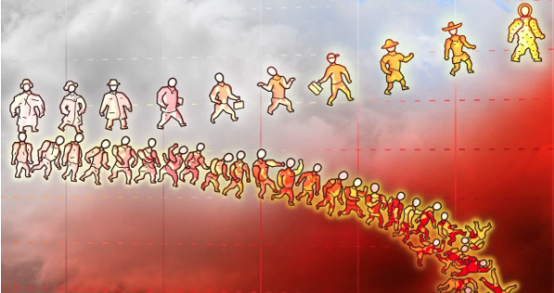
ON JULY 12, the Larsen C ice shelf in Antarctica lost a chunk of ice the size of Delaware, a small state on America’s east coast. America’s government seems unfazed by the possibility that such shifts might one day threaten Delaware itself. Its climate defiance grows not only from the power of its fossil-fuel industry and the scepticism of the Republican party, but also from a sense of insulation from the costs of global warming.
This confidence is misplaced. New research indicates not only that climate change will impose heavy costs on the American economy, but also that it will widen inequality.
Even a modest rise in temperature impairs American economic performance. An increase in global temperature of 1.5°C is very likely to reduce annual output by the end of the century by between zero and 1.7%; a rise of 4°C would probably generate losses between 1.5% and 5.6% of GDP. These figures mask considerable variation across America. In some parts of the country the models forecast a rise in local GDP of 10%; others face a staggering expected decline in annual output of 20%.
It is not surprising that the nationwide costs of climate change should conceal losses in some places and gains in others; that is how averages work. But the distribution of losses matters. The study shows that the pain of climate change will fall more heavily on America’s poorest than on its richest areas. Falling crop yields and labour productivity, and rising mortality and crime, are expected to be especially pronounced in America’s hot southern counties, where incomes are below the national average. In richer New England and the Pacific north-west, in contrast, winters will be milder and less deadly, and agricultural yields may rise. The aggregate economic cost of climate change is reduced because the burden disproportionately falls on those with low incomes, hardly the ideal way to slash the cost of warming.
The costs of global climate change will be unevenly (and uncertainly) distributed, but harm will often be smaller for richer, temperate countries. As a result the estimated economic loss from warming is almost certainly understated, because the nastiest effects are concentrated in places where incomes are lowest: and, correspondingly, where tumbling incomes have the smallest effect on global GDP. Uncertainty around economic projections is highest in the poorest countries. For some of these places the worst outcomes could mean GDP losses of 40% or more.
Yet just because a county in Mississippi faces a harsher future as a result of climate change than a county in Washington does not mean Mississippians must fare worse than Washingtonians. The authors hold the distribution of America’s population constant in conducting their analysis, but point out that harm could be reduced by large-scale migration. Is that a realistic possibility?
The rich are disproportionate contributors to the carbon emissions that power climate change. It is cruel and perverse, therefore, that the costs of warming should be disproportionately borne by the poor. And it is both insult and injury that the wealthy are more mobile in the face of climate-induced hardship, and more effective at limiting the mobility of others. The strains this injustice places on the social fabric might well lead to woes more damaging than rising temperatures themselves.

