Changing Importance of Other Energy Sources

Syllabus Link: The relative and changing importance of hydrocarbons, nuclear power, renewables, new sources of modern energy.

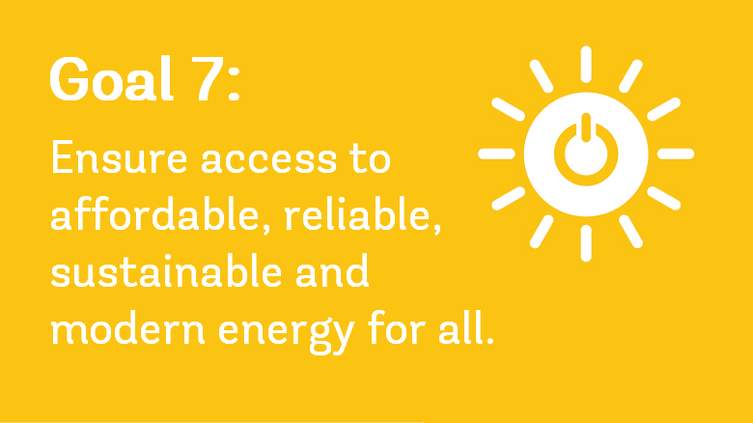

Task: You need to find details of and evaluate energy sources in terms of their importance for the future. You need to do this for:

- Hydrocarbons (oil
- Nuclear
- A major renewable
- A new source of modern energy

Energy Type: | Oil
Energy Source
Current usage (total and global patterns)
Positive Impacts
Negative Impacts
Evaluation as a future source of energy

Energy Type: | Nuclear
Energy Source
Current usage (total and global patterns)
Positive Impacts
Negative Impacts
Evaluation as a future source of energy

Energy Type:
Energy Source
Current usage (total and global patterns)
Positive Impacts
Negative Impacts
Evaluation as a future source of energy

Energy Type:
Energy Source
Current usage (total and global patterns)
Positive Impacts
Negative Impacts
Evaluation as a future source of energy

