Changing Urban Systems Activities

Syllabus Link
Urban system growth including infrastructure improvements over time, such as transport, sanitation, water, waste disposal and telecommunications

Part 1: Introduction
Take notes on what kind of changes are occurring in the intro video
Define urban infrastructure
Name essential types of urban infrastructure

Part 2: Urban Infrastructure Concepts
Describe the term networks and note some features
Explain why the terms capacity and sustainability are important concepts and inter-related
Describe how the structural layer impacts and is impacted by the other 3 layers in the diagram below
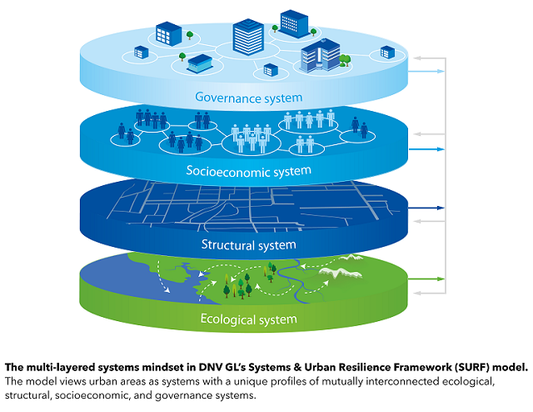
Layer | Impacts infrastructure | Impacted by Infrastructure
Ecological
Socioeconomic
Governance

Part 3: Case Study
Syllabus Link: Case study of infrastructure growth over time in one city
You need to conduct a case study investigation for either Shanghai or Singapore. Resources for this are either on adorngeo or google classroom.
Overview (introduction of relevant background information)
Transport
Sanitation
Water
Waste disposal
Telecommunications
Summary (one paragraph written summary or a mindmap)

