Beijing Air Pollution Case Study
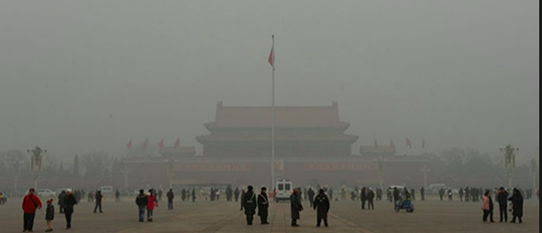

Syllabus Links
- Air pollution patterns and its management
- Case study of air pollution in one city and its varying impact on people

Describe the pattern of Beijing air pollution
What is happening

Scale of the pollution issue

Causes

General impacts

Impacts on people
Annotate the diagram below to show some of the impacts pollution can have on people in Beijing
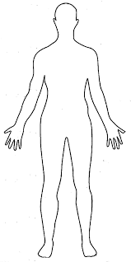
As well as impacts on people what other major impacts does Beijing air pollution cause?

Management of Beijing’s Air Polution
Take notes on what Beijing has done in relation to each of the 3 main management strategies
Replace
Restore
Replenish
Write paragraph to evaluate the effectiveness of Beijing’s pollution management

