Premier League going global
THE FORMATION OF THE PREMIER LEAGUE
The Premier League was formed in 1992 when the 22 First Division - as it was then - clubs resigned from the Football League and set up their own division in order to attract greater revenue from television. In 1992, broadcasting rights were assigned to subscription television service BSkyB, a move that charged fans for watching top flight football on their screens for the first time in England.
The Premier League is already the richest football league in the world, and it is likely to get even richer. Promotion alone to the Premier League from the Championship was last season valued to be worth about £200m for a football club.
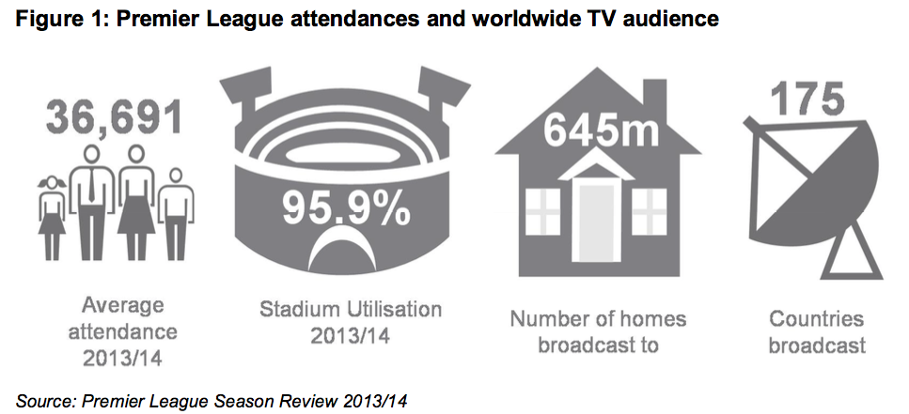
HOW SUPPORT WENT GLOBAL
1. WORLDWIDE TV COVERAGE
The continued growth and huge appetite of the Premier League's worldwide audience is the reason foreign broadcasters are prepared to spend such huge amounts to show English football.
Premier League games are broadcast to about 645 million homes in 175 countries worldwide, and they are particularly popular in Asia and the Middle East.
Long gone are the days when every Manchester United supporter came from Manchester, when every Liverpool fan was a born and bred Scouser. Today, following a football club is almost as easy in Thailand or Hong Kong as it is in England - and that is why clubs are increasingly turning to the overseas market in order to boost their fan base and, sure as night follows day, their revenue streams. A Liverpool fan in Thailand, for example, would be able to watch Liverpool in action at three o'clock (English time) on a Saturday, whereas a UK-based fan would not unless he or she was attending the game due to the nature of the TV rights package.
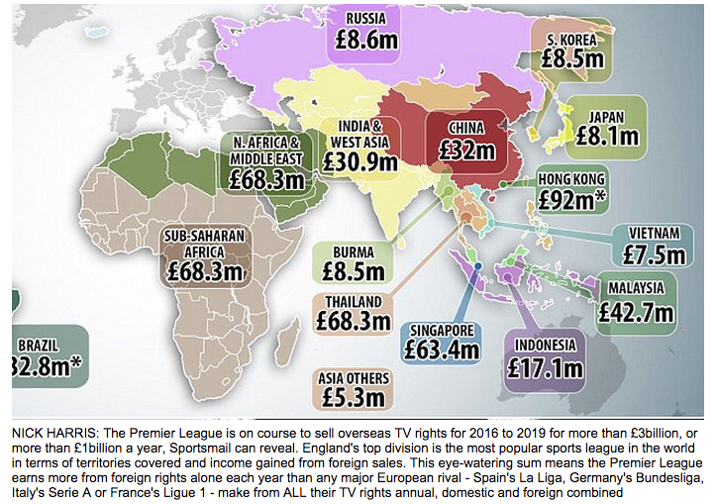
Thanks to improved revenues from TV rights, EPL clubs are spending more than ever, with the summer of 2016 breaking the record for transfer deal spending to over £1bn:
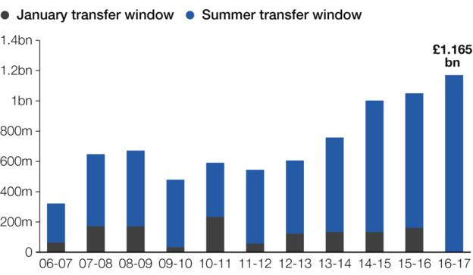

2. PRE-SEASON TOURS

Pre-season football goes global
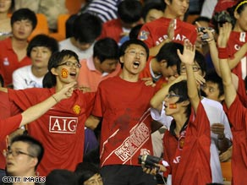
Preseason warm-up matches have always been a key part of any side's annual timetable, enabling squads to get to peak physical levels in time for the first match.
However, where once this would entail playing sides from the club's local area, a number of Europe's biggest sides are now seeking opposition from further afield -- many jetting around the world to find teams to play.
Manchester United taking on FC Seoul in Korea as part of their tour of Asia or Manchester City paying a visit to South Africa -- the trend is to travel long distances for a test of fitness.
But what is driving teams to undertake such arduous journeys and frenzied schedules so close to the start of a new campaign?
Much of the reason seems to be driven by business according to World Soccer magazine editor Gavin Hamilton. "Television rights are where clubs make most money, but increasingly they're looking to sell these rights abroad," he told CNN.
"This means they have to build new customer bases in foreign countries with a view to winning over more television rights in the future. At the moment, clubs make most of their money from fans who live very close to their ground. But in the future, they're looking increasingly to overseas fans [for revenue]."
Paul Barber, the executive director of English Premier League side Tottenham, had similar reasons to explain why his club travelled to Beijing, China for their fitness training. He said: "We believe it is very likely that these new partners will come from outside of Britain, so the chance to present our club and our team in new markets is very important. For clubs as big as we are, the revenues can be significant."
With an estimated 20 million fans worldwide, Barber feels there is a duty for a club that has benefited from the global appeal of the Premier League, to allow international fans to see the team at first hand.
Manchester United is in many ways the model of a globalized football brand with millions of fans the world over. A relentless schedule of global preseason tours -- that has included South Africa, the U.S. and South East Asia in recent years -- has seen the English champions listed by Forbes magazine as the richest football club in the world at the end of last season, with estimated earnings of $1.8 billion.

