Bangkok Air Pollution Case Study

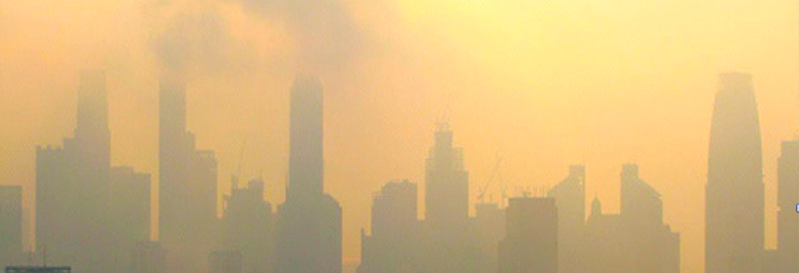

Syllabus Link | HL: Localized pollution  Urban: Air pollution patterns and its management

Introduction: Take notes from the general introduction video to air pollution

Bangkok Smog Crisis

What is happening?

When does this occur?

What is causing this?

Natural causes
Human causes

What are the impacts?

Social
Economic
Environmental
Political

What are possible solutions to Bangkok smog crisis?

