Aid in reverse: how poor countries develop rich countries

Jason Hickel January 14 2017

New research shows that developing countries send trillions of dollars more to the west than the other way around. Why?

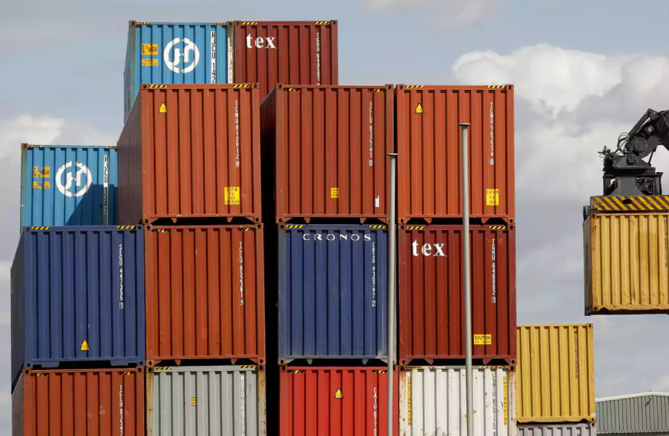
We have long been told a compelling story about the relationship between rich countries and poor countries. The story goes that the rich nations of the OECD give generously of their wealth to the poorer nations of the global south, to help them eradicate poverty and push them up the development ladder. Yes, during colonialism western powers may have enriched themselves by extracting resources and slave labour from their colonies – but that’s all in the past. These days, they give more than $125bn in aid each year – solid evidence of their goodwill.
But it may not be as simple as it appears.
The US-based Global Financial Integrity (GFI) and the Centre for Applied Research at the Norwegian School of Economics recently published some fascinating data. They added up all of the financial resources that get transferred between rich countries and poor countries each year: not just aid, foreign investment and trade flows but also non-financial transfers such as debt cancellation, transfers like workers’ remittances, and unrecorded capital flight. What they discovered is that the flow of money from rich countries to poor countries pales in comparison to the flow that runs in the other direction.
In 2012, the last year of recorded data, developing countries received a total of $1.3tn, including all aid, investment, and income from abroad. But that same year some $3.3tn flowed out of them. In other words, developing countries sent $2tn more to the rest of the world than they received. If we look at all years since 1980, these net outflows add up to an eye-popping total of $16.3tn – that’s how much money has been drained out of the global south over the past few decades. To get a sense for the scale of this, $16.3tn is roughly the GDP of the United States.
What this means is that the usual development narrative has it backwards. Aid is effectively flowing in reverse. Rich countries aren’t developing poor countries; poor countries are developing rich ones.
What do these large outflows consist of? Well, some of it is payments on debt. Developing countries have forked out over $4.2tn in interest payments alone since 1980 – a direct cash transfer to big banks in New York and London, on a scale that dwarfs the aid that they received during the same period. Another big contributor is the income that foreigners make on their investments in developing countries and then repatriate back home. Think of all the profits that BP extracts from Nigeria’s oil reserves, for example, or that Anglo-American pulls out of South Africa’s gold mines.
But by far the biggest chunk of outflows has to do with unrecorded – and usually illicit – capital flight. GFI calculates that developing countries have lost a total of $13.4tn through unrecorded capital flight since 1980.
Most of these unrecorded outflows take place through the international trade system. Basically, corporations – foreign and domestic alike – report false prices on their trade invoices in order to take money out of developing countries directly into tax havens and secrecy jurisdictions. Usually the goal is to evade taxes, but sometimes this practice is used to launder money or avoid capital controls.
Transnational companies also take money from developing countries by shifting profits illegally between their own subsidiaries by mutually faking trade invoice prices on both sides. For example, a subsidiary in Nigeria might dodge local taxes by shifting money to a related subsidiary in the British Virgin Islands, where the tax rate is effectively zero and where stolen funds can’t be traced.
Poor countries don’t need charity. They need justice. And justice is not difficult to deliver. We could write off the excess debts of poor countries, freeing them up to spend their money on development instead of interest payments on old loans; we could close down the secrecy jurisdictions, and slap penalties on bankers and accountants who facilitate illicit outflows; and we could impose a global minimum tax on corporate income to eliminate the incentive for corporations to secretly shift their money around the world.
We know how to fix the problem. But doing so would run up against the interests of powerful banks and corporations that extract significant material benefit from the existing system. The question is, do we have the courage?

Edited from: https://www.theguardian.com/global-development-professionals-network/2017/jan/18/its-not-aid-in-reverse-illicit-financial-flows-are-more-complicated-than-that

