Advancing & Retreating Coasts Worksheet

Syllabus Link
Advancing and retreating coastlines, including the role of isostatic and eustatic processes, and the associated landforms (relict cliff, raised beach, fjord)

Section A: Definitions, Descriptions, Short Answer

- Define Isostatic and Eustatic Processes (4)

- List 3 Submergent Landforms (3)

- List 3 Emergent Landforms (3)

- Draw and Label the process of Isostaic and Isostatic Re-adjustment process of Glaciers. (4)

Section B: Explanations, Processes, Application, Concepts

- Explain the process of landforms that are created by EITHER eustatic or isostatic changes in sea level (6)

- Fill in the chart on landform features in the following chart. (5)
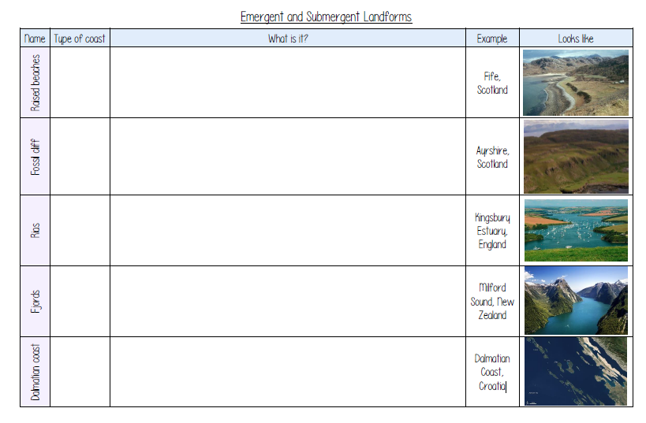

- Read the following Information and answer which landform features are expected to be in the north and west of the UK versus the south and east. Explain why. (3x3)

Eustatic changes occur relatively quickly but isostatic changes take much longer. Despite melting of ice over 8,000 years ago, the UK is still uplifting. Land in the north and west (which was covered by ice) is rising as a result of isostatic recovery. Land in the south and east (which was not covered by ice) is sinking. Sediment deposition is causing the crust to sink and relative sea levels to rise.

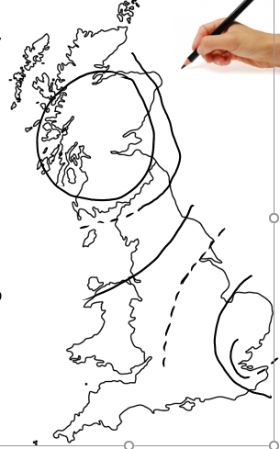
North and West

South and East

Section C: Long Answer. Structure Paragraph Response. Case Study/Examples Needed. Argument/Fence sitting.

- Evaluate the recent geographical isostatic and eustatic changes in one or more coastal landscape (10)

- Using examples, evaluate the impact of global warming on coastlines globally (10).

