Traffic Congestion – An Urban Stress

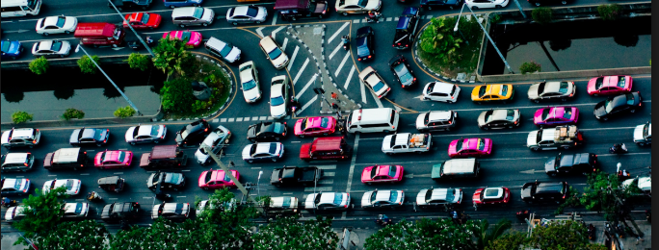

Syllabus Link
- Traffic congestion patterns, trends and impacts
- Case study of one affected city and the management response

Patterns & Trends
Use the Tomtom traffic on adorngeo index to show the top 5 most congested cities in 2016
Rank | City | Trend in traffic congestion | Notable point
1
2
3
4
5
Make a comment linking the top cities in the Tomtom index to a pattern
What is the trend of traffic congestion in these already congested cities?
Why are these cities so congested?

Bangkok Traffic Case Study
Describe the pattern of traffic congestion in Bangkok
Describe the trend of traffic congestion in Bangkok (use the Tomtom index & graphics)
State some important specific facts about Bangkok Traffic
Use SEEP analysis to show the causes and consequences of traffic congestion in Bangkok
Factor | How it causes congestion | Consequences of congestion
Social
Economic
Environmental
Political
What management strategies have been applied to manage Bangkok’s traffic?
To what extent have the management strategies applied in Bangkok been successful?

