Sustainable City Case Studies

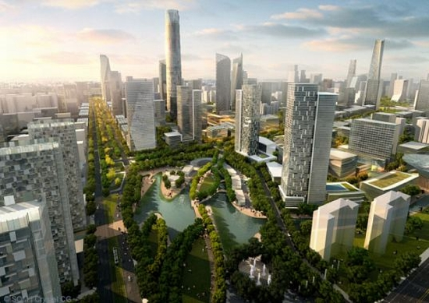

Syllabus link
Eco city design, including strategies to manage the urban ecological footprint
- Two detailed examples to illustrate possible environmental strategies
Smart city design and the use of new technology to run city services and systems, including purpose-built settlements and retrofitting technology to older settlements

Task: In groups of 3 you are to research a case study of as a city that practices both eco and smart city strategies. You have to:

- Research into your assigned city. The cities are Songdo in South Korea or Singapore.
- Prepare a google doc briefing that summarises your city for the rest of the class. The summary should be simple in format and clear and concise and needs to include appropriate visuals.

Required Knowledge: as the syllabus link above shows you need to know about:

- A quick background on the design strategies to make the city more eco-friendly. You need an over view of this and at least 2 detailed strategies.
- Smart city features integrated or built into the city. Highlight key technologies and their impacts on the city.
- Evaluate the effectiveness of your strategy
- Connect to Bangkok by suggesting 5 eco and smart strategies that could benefit this city (and explain how they could bring about positive change)

To link to more parts of the syllabus you need to describe the city as a system in terms of:

- Inputs—energy, water, people, materials, products, food (urban agriculture)
- Outputs—solid, atmospheric and liquid waste, noise, people.
- Distinguish between a sustainable circular system where inputs are reduced and outputs are recycled and an unsustainable (open/linear) city system with uncontrolled inputs and outputs.

Resources: On adorngeo or loaded to google classroom

