NIST DP Geography

INTERNAL ASSESSMENT GUIDE

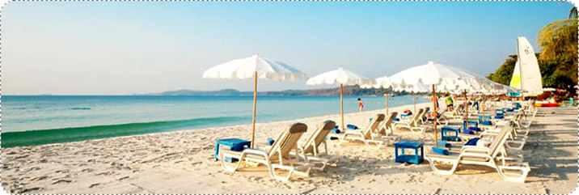

An investigation into tourism development on Ko Samet

Name: _____________________________
Introduction

Your internal assessment is a form of geographic inquiry and will focus on investigating tourism development on Ko Samet.

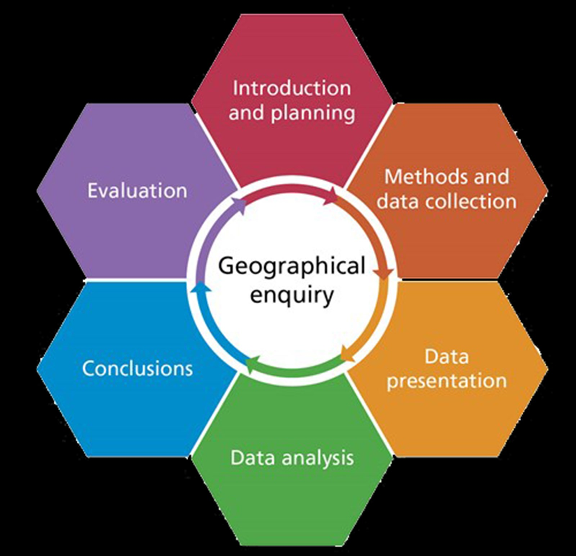

This guide will help you at every stage of the investigation process – in preparing your methods you will use for your investigation, carrying out field work when we are on Ko Samet, and in individually writing it up afterwards.

It is divided into the following sections:

- A summary of tips
- A step by step guide to the IA
- The mark scheme
- Data gathering, statistical & presentation techniques
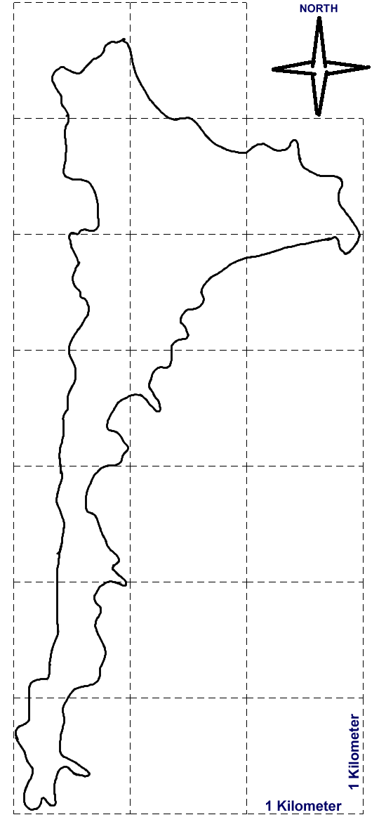
Geography IA: Steps for Success

Investigate and get to know Ko Samet
- Describe attractions and reasons it is a hotspot
- Find visitor numbers and types and highlight how tourism development has evolved on the island
- Consider why it may be a good location to analyze tourism using Butler’s model
- Make use of Google earth or maps to get to know the island
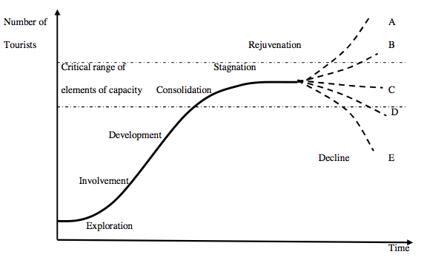 | Learn about Butler’s Model  - Get to know the stages well  - Determine factors that indicate which stage of the model a place is and incorporate this into your methodology  - Link it to the geography syllabus  - Refer back to it constantly in your analysis
Plan your methodology
- Determine what are the important aspects of tourism development and of Butler’s model that could apply to Ko Samet
- Design surveys to ensure you collect the correct qualitative data
- Plan techniques to collect the quantitative data you need and ensure you have all required equipment, surveys and base maps etc before you leave
Work as a team to collect your data
- Work as a team throughout the trip
- Do as much fieldwork as you can when there
- Process your data as much as possible on the trip
- Make sure all the information you collect is secure and shared
Use your time on Ko Samet wisely
- Do as much fieldwork as you can on the trip
- Reflect on your first data collecting opportunities and modify techniques if needed
- Make the most of evening sessions to try to complete at least your intro, methodology, and evaluation while on Ko Samet
Process your data
As a group
- Process your surveys to get raw data totals
Individually
- Process your data to show patterns and trends
- Try to use statistical techniques if possible
Create visuals
- Use tools such as Excel, Pixlr Editor, Piktochart, Google Earth, Google Draw, etc
- Create a variety of visuals including annotated photos
- Ensure that you include some spatial mapping

Get analytical
- Refer specifically to the patterns/ trends displayed in your visuals
- Use formal analytical language
- Recognize and account for any anomalies
- Ensure all of your analysis links back to the research question and relates to Butler’s model

Produce your final draft
- Structure your report as required and follow all required conventions for formatting, layout and referencing
- Ensure you stay within the 2500 word limit
- Edit it fully before you hand it in
- Important: Your final draft should be what you consider to be the finished IA
Reflect on advice and produce final version
- Pay attention to all advice offered as feedback
- Act on feedback as quickly as possible
- Make use of the IA final checklist
- Ensure you hand it in on or before the due date

WHAT IS REQUIRED - SECTION BY SECTION

The Geography Internal Assessment follows a sequence of six sections. It’s a little like a Science lab report that follows a process of inquiry. Your report of 2,500 words maximum should be divided into the following:

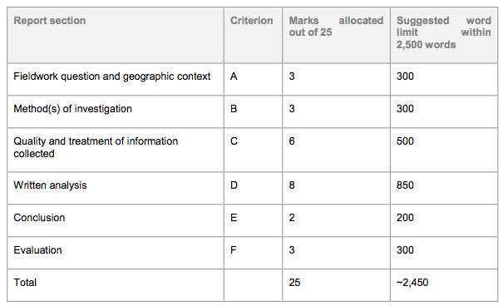

The suggested breakdown of the word limit is offered as guidance and is not prescriptive. Students will not be penalized if they write more or less for each section provided the work remains within the total word limit of 2,500 words.
A word of warning. You MUST NOT exceed the word limit of 2500 words. If you do you will be penalized

WHAT TO INCLUDE - SECTION BY SECTION

Section 1: Fieldwork question and geographic context

- 3 marks out of the 25 available
- Suggested word limit: 300

This section introduces the investigation and states its aim to answer a fieldwork research question. You must comment briefly on the geographic context, explaining why and where the fieldwork investigation is to be carried out. A map of the research area and/or the locations used in the fieldwork investigation is essential to provide the necessary spatial element.
Steps:

Research Question: Clearly state your chosen fieldwork question (as a question with a ?). You will investigate this fieldwork question:

“To what extent does tourism development on Ko Samet fit the stages of Butler’s model?”

Location: You must include a map (preferably hand-drawn or created by you on your computer with a scale, North sign, and labels highlighting key features) to clearly locate Ko Samet within this region of Thailand. Examiners do not like “inferior” downloaded maps from the internet, although you can manipulate a Google Earth one. Another map of the specific study site in Ko Samet is also essential. You can re-use this map to present data later in the report.

“Geographic context”: It is very important to explain why Ko Samet is a good location to investigate your fieldwork question – as a location to test Butler’s model, to explore sustainable tourism/carrying capacity in the context of the environmental impact of tourism. Think about it … why is Ko Samet a good place to study the impact of tourism compared to the carrying capacity of the destination? Why might the fact that it is an island and a national park be significant too?

You must briefly state the area(s) of the Geography syllabus to which your investigation and geographic context relates. The syllabus area most likely to relate to your investigation is in this section:

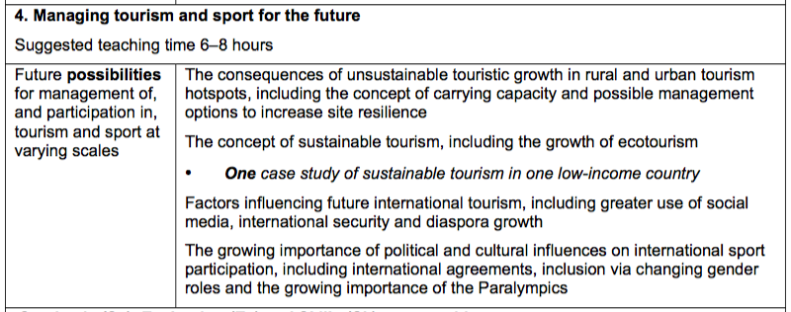

There is a temptation to make the introduction long and spend hours getting it perfect. Don’t. For one, it’s worth only 3 of the 25 marks, and you can clean it up later!

Criterion A Summary
This criterion assesses: | To attain full marks you must:
the focus and geographic context of the fieldwork and to what extent the link between the fieldwork question and the geographic context (that is, material in the syllabus, a relevant syllabus topic or geographical theory) is made clear. The fieldwork question should be specifically geographical. | The link between the fieldwork question and the relevant syllabus topic, the syllabus or geographical theory is described.  The fieldwork question is geographical and focused, clearly identifying a precise location allowing for primary data collection within the limits of the internal assessment.  One or more locational maps are presented and follow mapping conventions, providing clear information and details of the fieldwork location. A visual of Butler’s model is included.

Section 2: Methods of investigation

- 3 marks out of the 25 available
- Suggested word limit: 300

Identify what data you need to collect (linked to your fieldwork question, and hypothesis if you have one) then explain how you collected that data as detailed below.

Describe and justify the methods that you used to collect your information in detail, including a ‘pilot’ of your questionnaire(s), sampling techniques and sample size (a minimum of 30 questionnaires!), time of day, etc. Methods also include observations and site surveys, satellite and digital photo analysis that you can annotate, interviews,
counts of people, facilities or transport modes etc, field sketches. It’s a good idea to include a map with the location of the beaches you will use in your analysis.
You need to collect a variety of qualitative and quantitative data but make sure it is all relevant to your fieldwork question.

Possible ways of collecting data on Samet
You won’t collect data on every beach, but need to choose 4-5 contrasting ones.

- Number of people along a beach at different times of day
- Number of tourist-related services (restaurants, restaurant/hotels, shops, tour operators – classify!) per beach
- Number of boats per beach at different times of day
- Boat timetables to gauge accessibility to the island in different places
- Classify heavy, medium, low environmental impact of tourist activities by using the Leopold index
- Environmental quality index surveys on different beaches (to see impact of tourism)
- Sound level meter or equivalent using a phone app to take a reading on each beach at different times of day
- Take photos of each beach under investigation, which can be annotated later.

Interviews or questionnaires with longstanding (10+ years) residents to find out:
- How has the island changed over time – hotel/land ownership, numbers of visitors, evidence of resentment amongst island residents
- Their degree of involvement in tourism on the island - % of income?
- Level of satisfaction with tourism

Short questionnaires of tourists/residents to find out:
- Returning or first time visitors
- Age/gender
- Where they are from and why they came to Ko Samet
- Questions to gauge their perceptions of environmental quality (“perceptual” carrying capacity) and of the impact of tourism
- Types of activities that they do on the island

For each method it’s really important that you state how/why it helps you answer your fieldwork question. A really good technique is to annotate your questionnaire(s) with text boxes alongside the questions to explain why you chose them.

Secondary data and information should support your investigation; you need to be an expert on your selected topic! Start by completing your getting to know Ko Samet homework and make use of the resources on adorngeo. You then need to do your own wider or follow up research.

A strong word of warning:

Although you will be working in groups to collect data in Ko Samet, after that all the work on your IA must be completed on your own. Collusion (ie sharing your work) is a serious offence that can lead to disqualification in IB Geography!

Criterion B Summary
This criterion assesses: | To attain full marks you must:
the description, justification and appropriateness of the method or methods including sampling and surveying techniques, primary or secondary data collection as appropriate used to investigate the question formulated. | The method(s) used for information and data collection are described, explaining clearly and accurately how the combination of data collected is relevant to the theory, question formulated or the hypotheses for the internal assessment. They may describe statistical tests if appropriate.  The method(s), data collection instruments/technologies and sampling/surveying techniques are used correctly, resulting in reliable and good quality primary data supporting a relevant quantitative and/or qualitative analysis.
Section 3: Quality and treatment of information collected

- 6 marks out of the 25 available
- Suggested word limit: 500

You should combine sections 3 & 4 together; Section 3 is worth 6 marks and Section 4 8 marks. 1,350 words is the suggested word limit for both sections combined.

The focus of this section of the report is to treat and display the information collected using the most appropriate techniques. These techniques must be the most effective way of representing the type of information collected and must be well used. The precise techniques employed will differ depending on the nature of the fieldwork question but may include statistical tests, graphs, diagrams, maps, annotated photographs and images, matrices, spatial maps and field sketches.
Students must also refer to the geographic context, information collected and the ways in which the material has been treated and presented.
For Section 3, you need to turn your data into visuals. Think about what we have done in terms of analyzing infographics and try and create your own powerful visuals. Variety is the key to success here, and the more you use maps, the better. Think about people or boat counts represented on a map, try and use spatial maps to display proportional date, or link annotated photos with specific locations on a map.

Think of techniques you already know: flow line maps, proportional circles, density dot maps, correlation tests … we will introduce you to a few more, like the Chi-Squared statistical test to statistically test distribution of something. Most importantly, you do not want to include a random selection of pie charts etc from Excel’s Chart Wizard! There are a good variety of useful tools to help you create your visuals, there are some on adorngeo and we will have a class session on this. Also don’t overlook the usefulness of google earth to give you great visuals you can analyze.

All maps, diagrams, photos, graphs need a figure number so you refer to them as ‘Figure 1 shows …’ etc. You must refer to them (don’t include any visuals that aren’t referred too!) and only includes ones that are relevant to your fieldwork question! All maps, diagrams and photos need to be cited too.

It’s a good idea to think about what types of visual you could produce before you go so you can collect appropriate information on the trip.

Criterion C Summary
This criterion assesses: | To attain full marks you must:
the quality of information and data collected and its suitability for analysis in criterion D, whether it is appropriate and a sufficient range of techniques have been used for the presentation of information, and whether the presentation follows accepted conventions (that is, the numbering, labelling, and annotating of tables, graphs and diagrams). | The information and data collected is all directly relevant to the question formulated or the hypotheses, and is sufficient in quantity and quality to allow for analysis or answering of the question formulated.  The most appropriate techniques have been used effectively for the presentation of information and data collected.  The graphs, tables, diagrams or other illustrations follow conventions (labelling, titles, and so on).

Section 4: Written Analysis

- 8 marks out of the 25 available
- Suggested word limit: 850

Section 4 holds almost a third of all the marks and is therefore the most important section!

In the written analysis, students must demonstrate their knowledge and understanding of the fieldwork investigation by interpreting and explaining the information they have collected in relation to the fieldwork question. This includes recognizing any trends and spatial patterns found in the information collected. Where appropriate, an attempt should be made to identify and explain any anomalies.
The treatment and display of material and the written analysis must be integrated within this section.
Identify patterns in the data, quoting specific examples/numbers/views expressed in interviews. You then need to interpret these in relation to your fieldwork question. Phrases like, “this would indicate that”, “perhaps this is because” etc should feature heavily.

Point out any differences/contradictions/anomalies and try to explain them.

When you can, connect the patterns/trends you have identified by cross-referencing different parts of your data; for example, does a response in an interview fit or contradict a pattern that you collected on another beach?

Bring in the bigger picture of what you have studied on tourism generally – social/economic/environmental costs, carrying capacity and how it can be increased, sustainable management of tourism, etc. If you can link to secondary data you must do so.

You need to use the PEEL format for each section of your analysis. In needs to be written formally and structured in the appropriate format. For each indicator of Butlers model you choose to analyse it’s important that you link it back to Butlers model.

Criterion D Summary
This criterion assesses: | To attain full marks you must:
the quality of the analysis of the results, referring to:  - links to the question and hypotheses formulated  - geographic context (that is, geographical theory, the syllabus, or the relevant syllabus topic)  - information collected  - statistics used (descriptive techniques—that is, graphs, charts, histograms and so on; as well as statistical techniques—that is, correlations, regression and so on)  - illustrative material. | The written analysis includes descriptive and statistical techniques (with confidence levels if appropriate) that are appropriate to the data and the question formulated.  The trends, patterns and statistics found, including outliers and anomalies if present, are explained and linked to the question formulated, hypotheses, geographical theory, the fieldwork location and methods used.  The written analysis allows for answering the question formulated, with no or only minor gaps in the supporting evidence.

Section 5: Conclusion

- 2 marks out of the 25 available
- Suggested word limit: 200

This is where you summarize the main findings from your fieldwork and analysis. There should be a clear, concise statement answering the fieldwork question.

Highlight which parts of your data collection particularly prove your answer to your fieldwork question?

It is no problem if your findings do not match your initial prediction/hypothesis or give a negative response to your fieldwork question … but if this is the case, add a little explanation for why this is the case. Remember that there are a number of beaches on Ko Samet and they may not all be at the same stage of Butler’s model.

Whatever you write in your conclusion, it must logically follow on from your written analysis … you shouldn’t be adding in new ideas at this stage!

It can be useful in a number of ways to include a visual as part of your analysis and this can help you save words.

Criterion E Summary
This criterion assesses: | To attain full marks you must:
the ability of the student to summarize the findings of the fieldwork investigation and draw a supported conclusion. | There is a clear conclusion to the fieldwork question, which is supported by the analysis.

Section 6: Evaluation

- 3 marks out of the 25 available
- Suggested word limit: 300

You need to review your investigative methodology, including methods of collecting primary information. Within this, you should consider any factors that may have affected the validity of the data, including personal bias and unpredicted external circumstances such as the weather.
You need to think critically and should suggest specific and plausible ways in which the study might have been improved and could be extended in the future.
Factors to think about include the wording of fieldwork question (and/or hypothesis), sample sizes, the potential for personal bias, bias in response to questionnaires and interviews, and the time of day/year when you carried out your investigation.

Do not claim, “I didn’t have enough time” or “my group didn’t work very well together”!

Suggest ways in which the investigation could have been improved if you did it again, and how changes could impact positively on the fieldwork. You can also maybe suggest further avenues of enquiry if you were taking the investigation further.

You should identify at least 3 weaknesses of your investigation and need to have a suggested improvement for each of the weaknesses you identify.

Criterion F Summary
This criterion assesses: | To attain full marks you must:
the student’s ability to review the investigative methodology, by weighing up the strengths and/or weaknesses of the chosen method, and suggest improvements. | The most appropriate and relevant strengths and/or weaknesses are explained regarding the data collection methods, the formulation of the fieldwork research question, the presentation of data/information and the choice of location. Suggestions for improvement are outlined and the potential impact of these improvements is explained.

Written Reports
You must produce one final investigation report. The report must not exceed 2,500 words.
A BIG word on word count

Examiners are very strict on the maximum word count of 2,500, and you must not go over it. They will stop reading once the limit has been reached. If you do, you will lose marks on criterion E (conclusion) and F (evaluation) of the mark scheme as well. In the worst case scenario, you could lose around 10 of the total 25 marks marks!!

You must indicate the total word count on the cover page.

Words that aren’t included in the word count:

- Title page
- Acknowledgments
- Contents page
- Titles and subtitles
- References
- Footnotes—up to a maximum of 15 words each
- Map legends and/or keys
- Labels—of 10 words or less (annotations!)
- Tables—of statistical or numerical data, or categories, classes or group names
- Calculations
- Appendices—containing only raw data and/or calculations

Words that are included in the word count:

- Main text: sections 1-6 above
- Words contained in text boxes
- Annotations/labels of more than 10 words

One way to get round the word count is to use more annotated diagrams/photos/maps instead of writing paragraphs! But pay attention to this advice from examiners:

“It appears that some schools are misinterpreting the use of text boxes, which must be associated with a diagram or illustration. ‘Deliberate attempts' to avoid the word count are not allowed, which is where students simply place text in a box to look different.

It is important to note therefore that labels and tables which draw attention to a feature in an illustration are valid but if the feature is not visible and is for example, a generalisation or theory put into a box then it serves no valid purpose.
If students are over the word count moderators will stop reading - this will not be treated leniently”.

References

Include websites as well as any printed material, and use the MLA format for all of these (see above the section on formal requirements). Again see the PPT on how to set out a list of works cited on the Internal Assessment wiki

Make sure you include the books listed below in your list of works cited. You will use them in some way through hand-outs/booklets given to you, even if you don’t see the original book:

Holmes, D & Farbrother, D. 2000. A-Z Advancing Geography: Fieldwork. Geographical Association.

Holmes, D & Warn, S. 2003. Fieldwork Investigations: A Self-Study Guide. Hodder Education.

Lenon, B & Cleves, P. 1994. Fieldwork Techniques and Projects in Geography. London. Collins Educational.

Nagle, G. 1999. Tourism, Leisure and Recreation. Surrey, UK. Thomas Nelson & Sons Ltd.

Citing interviews

You need to cite all interviews and photos etc that you include in your IA. You can finds information on how to cite in your IA on adorngeo.

The mark scheme!

Criterion A: Fieldwork question and geographic context
This criterions assesses the focus and geographic context of the fieldwork and to what extent the link between the fieldwork question and the geographic context (that is, material in the syllabus, a relevant syllabus topic or geographical theory) is made clear. The fieldwork question should be specifically geographical.
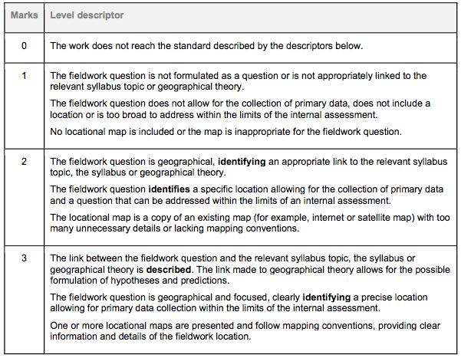

Criterion B: Method(s) of investigation
This criterion assess the description, justification and appropriateness of the method or methods including sampling and surveying techniques, primary or secondary data collection as appropriate used to investigate the question formulated.

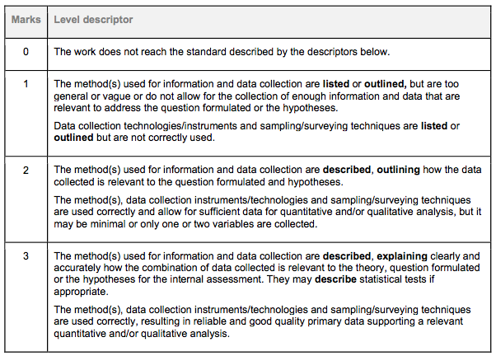

Criterion C: Quality and treatment of information collected
This criterion assesses the quality of information and data collected and its suitability for analysis in criterion D, whether it is appropriate and a sufficient range of techniques have been used for the presentation of information, and whether the presentation follows accepted conventions (that is, the numbering, labelling, and annotating of tables, graphs and diagrams
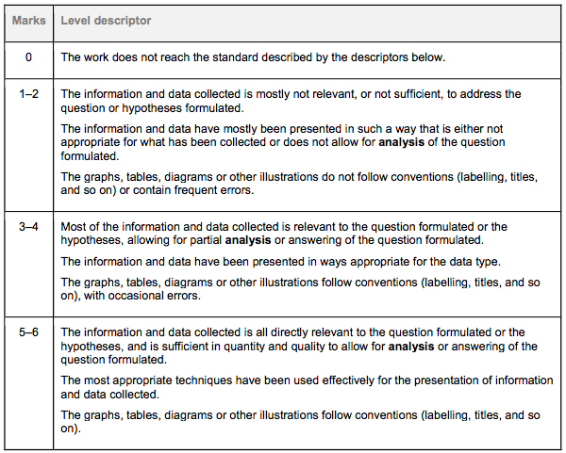

Criterion D: Written analysis
This criterion assesses the quality of the analysis of the results, referring to:
- links to the question and hypotheses formulated
- geographic context (that is, geographical theory, the syllabus, or the relevant syllabus topic)
- information collected
- statistics used (descriptive techniques—that is, graphs, charts, histograms and so on; as well as statistical techniques—that is, correlations, regression and so on)
- illustrative material.

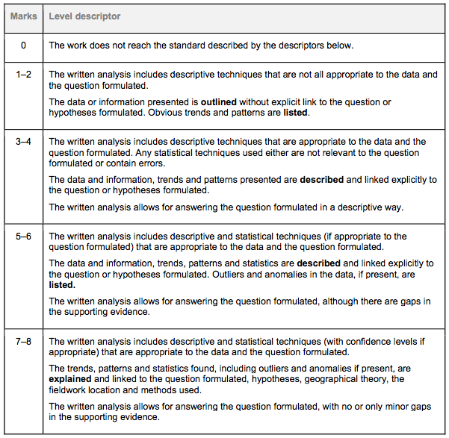

Criterion E: Conclusion
This criterion assess the ability of the student to summarize the findings of the fieldwork investigation and draw a supported conclusion.
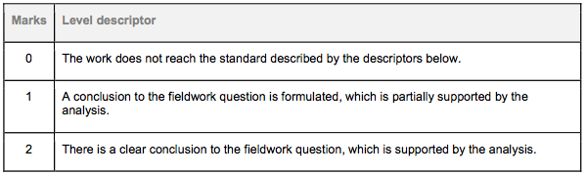

Criterion F: Evaluation
This criterion assesses the student’s ability to review the investigative methodology, by weighing up the strengths and/or weaknesses of the chosen method, and suggest improvements.
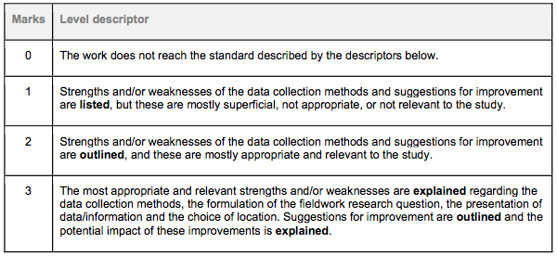

Notes

