Changes in the Global Energy Balance
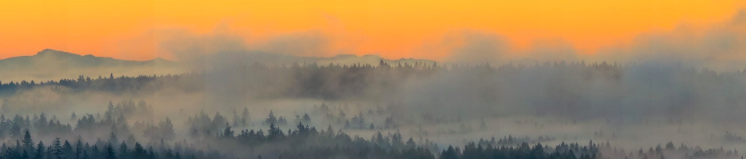

Syllabus Link: Changes in the global energy balance, and the role of feedback loops, resulting from:
- solar radiation variations, including global dimming due to volcanic eruptions
- terrestrial albedo changes and feedback loops
- methane gas release and feedback loops
Climate Change Evidence
What evidence is there for historic climate change?
What has happened to the rate of climate change in the last few decades?
What seems to be the main cause of the increased rate of temperature change?

Feedback
What are feedback loops?
Describe positive feedback and give an actual example of this
Describe negative feedback and give an actual example of this

Solar Radiation Variations
Take notes on the following
Changes in solar outputs
Changes in earth’s orbit
Explain global dimming and give a case study example for this
Changes in the natural carbon cycle
Explain what albedo is and how changes in this can lead to feedback loops

Terrestrial Albedo
Explain what terrestrial albedo is and how changes in this can lead to climate change
Give an example of a feedback loop

Methane Gas Release
What is methane gas release and where does this occur
Give an example of a feedback loop for methane gas

